**Text Mining with no code tool Orange**

Step 01 – Construction of the flowchart

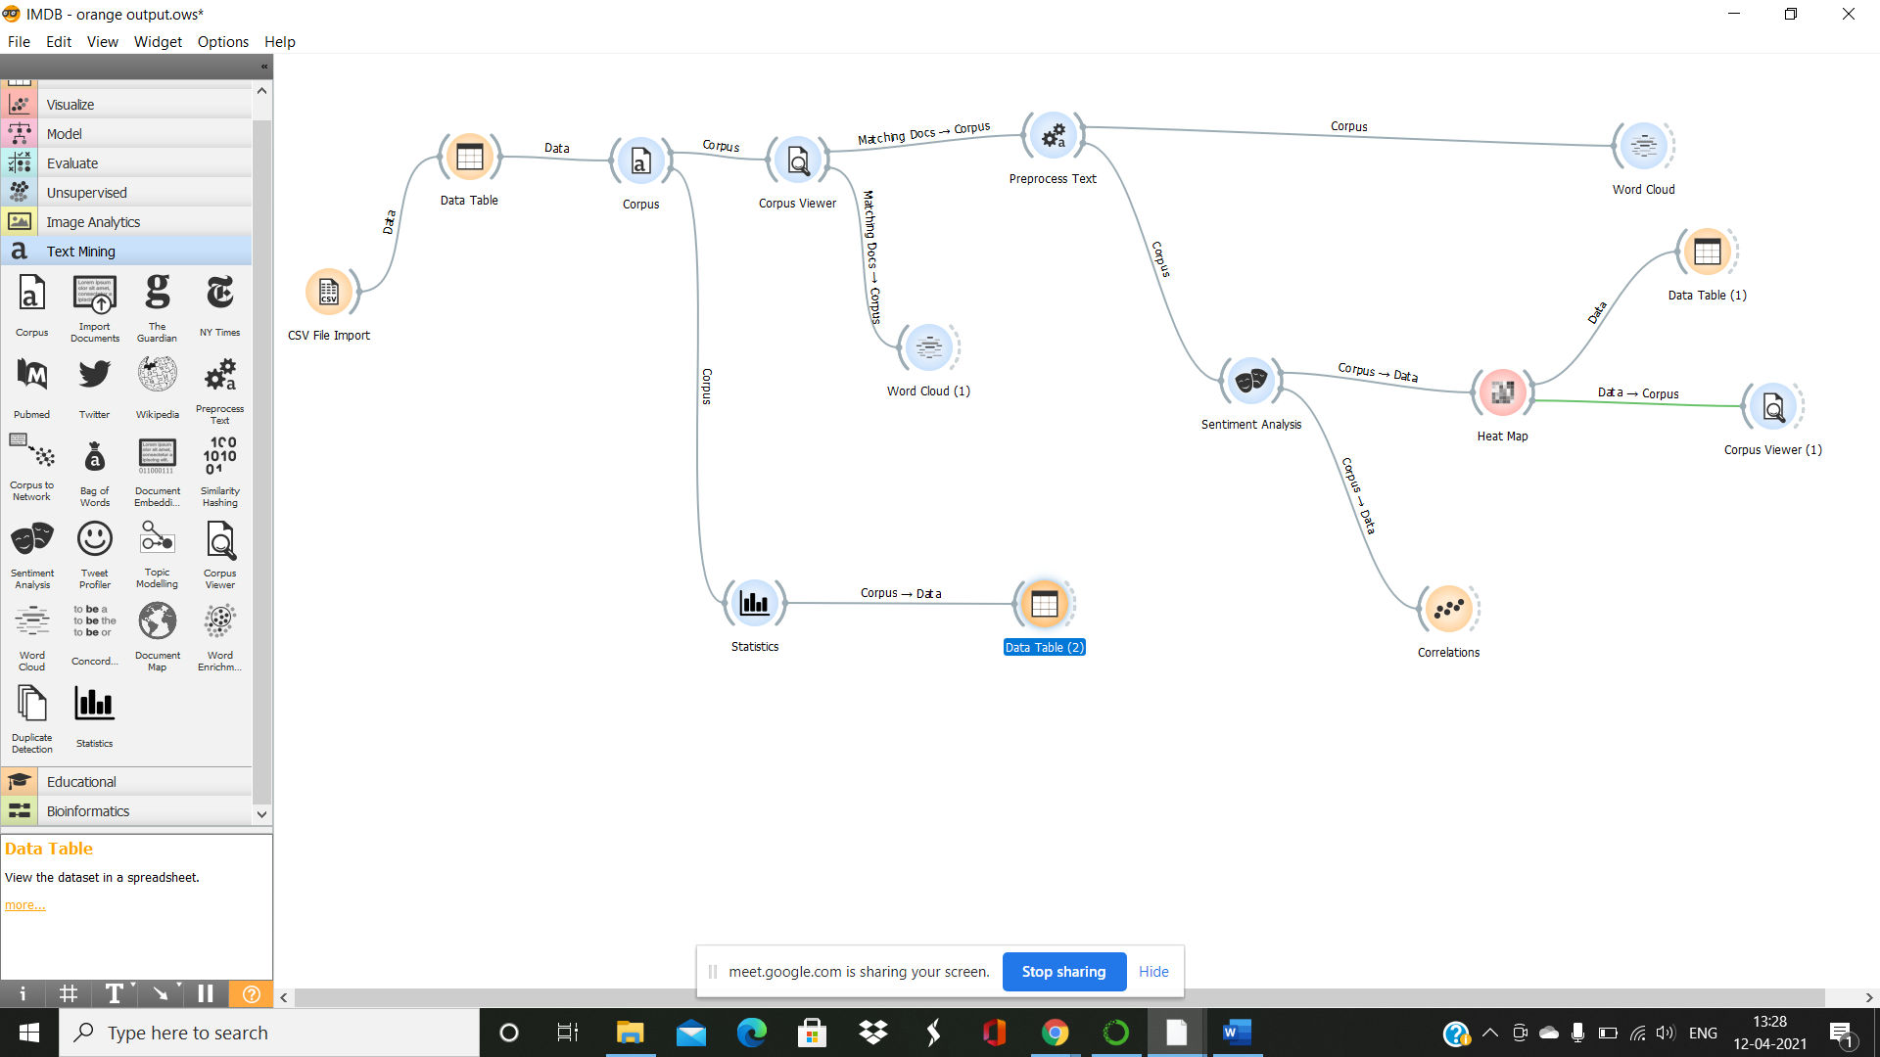

Step 02 – Plotting the clusters

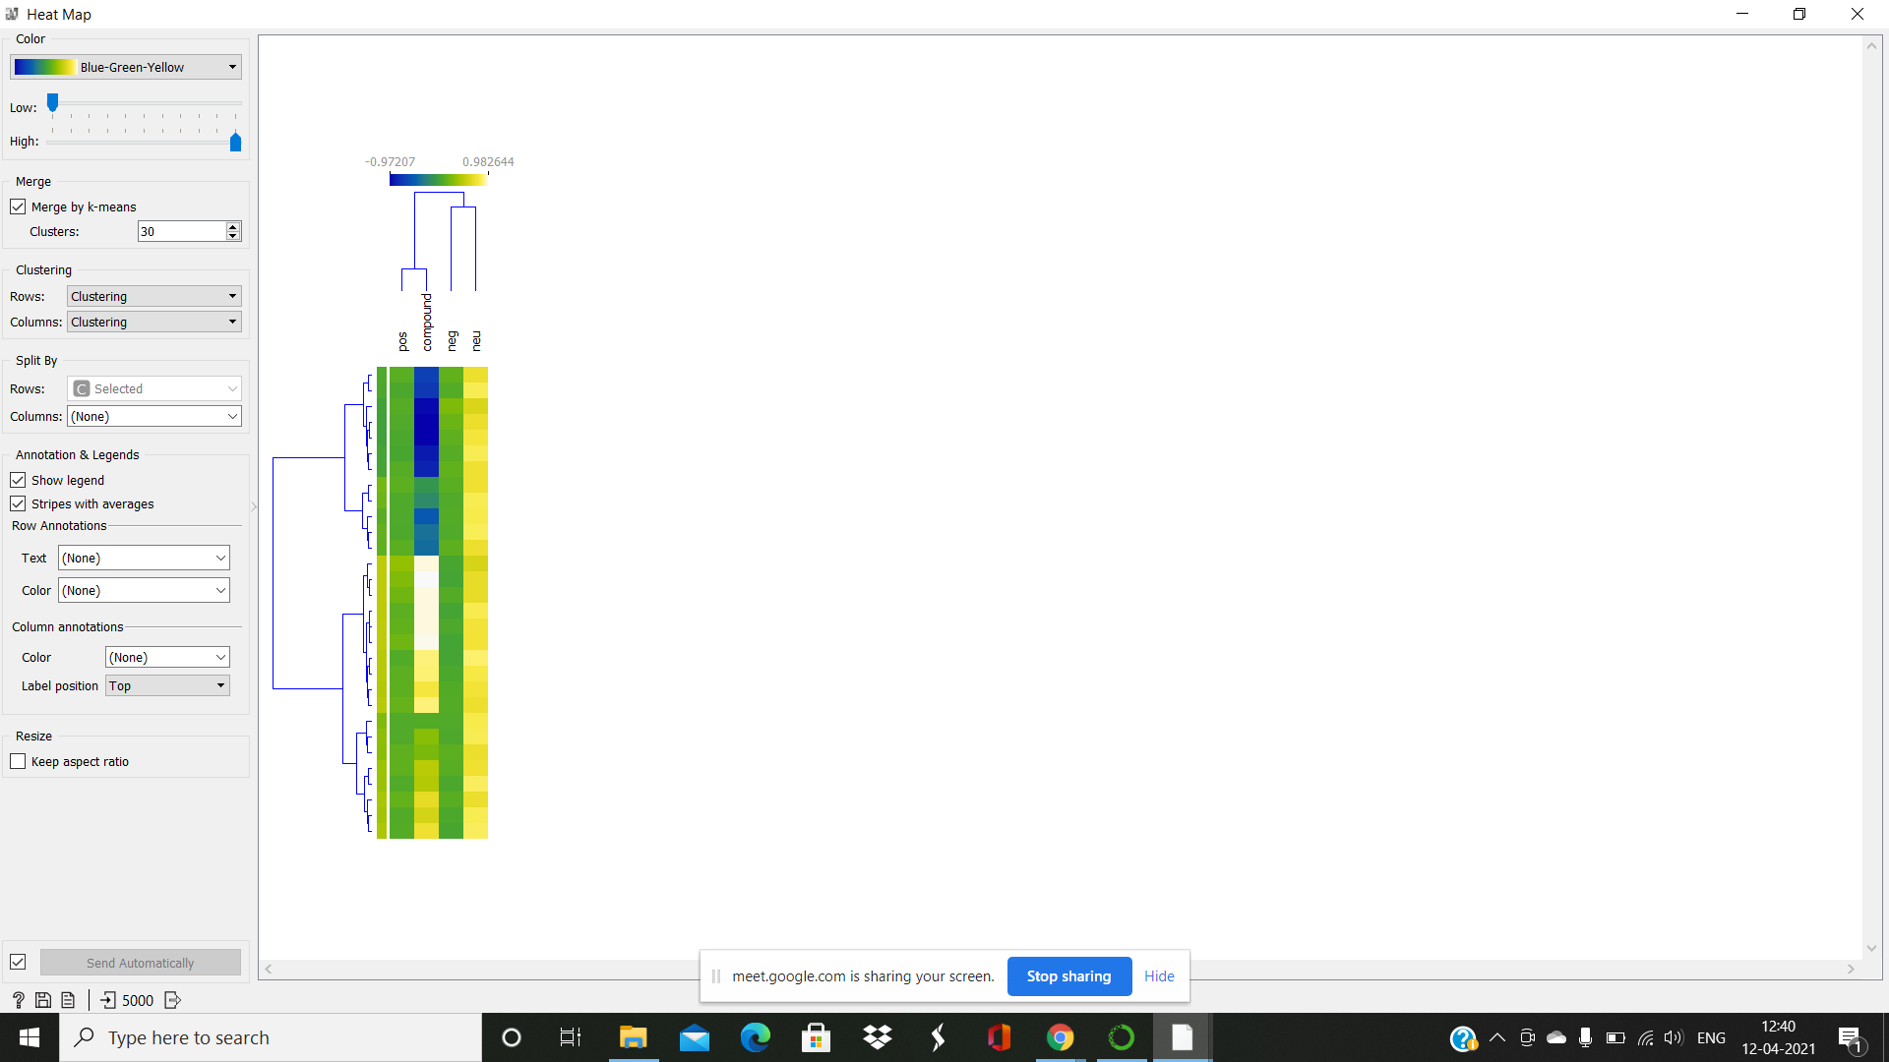

Step 03 – Heat map to understand the sentiments of viewers regarding the movie

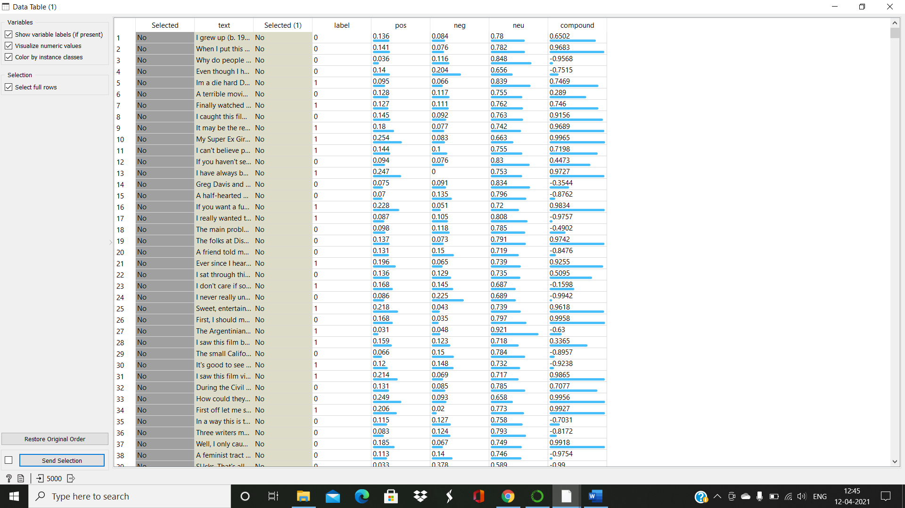

Step 04 – Plotting of word cloud prior to processing the data

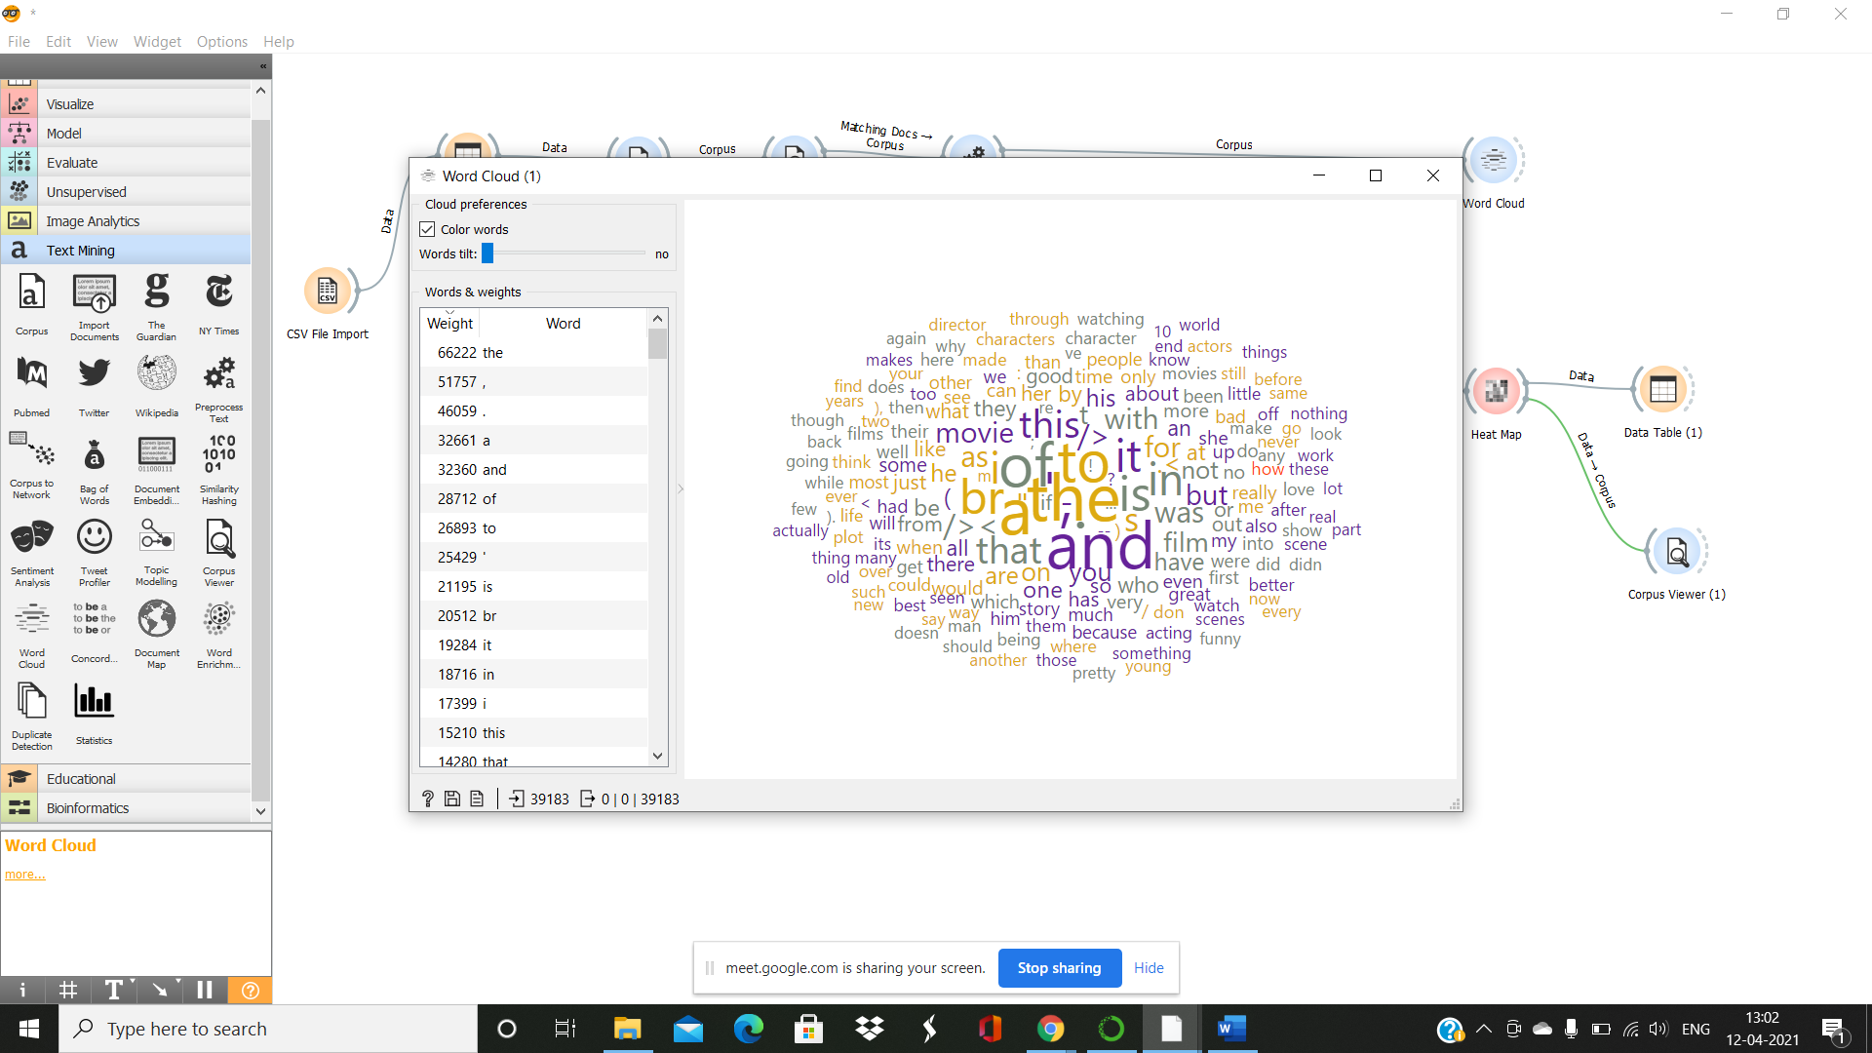

Step 05 – Plotting of word cloud after processing the data

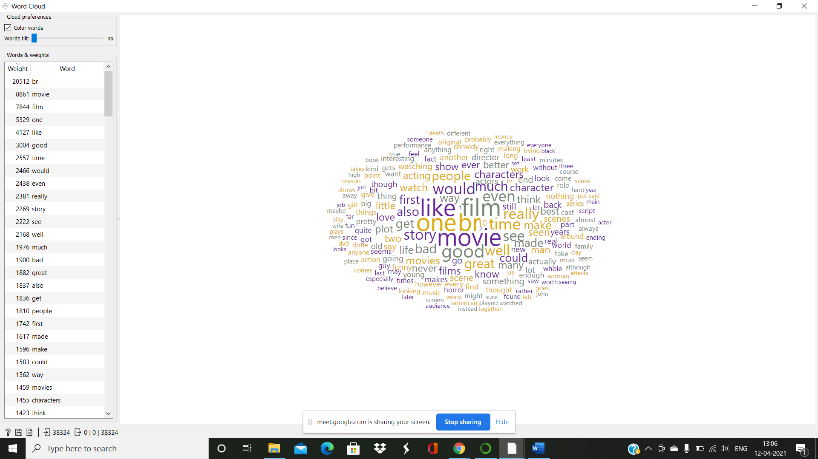

Step 06 – Corpus viewer to get more insights about each review

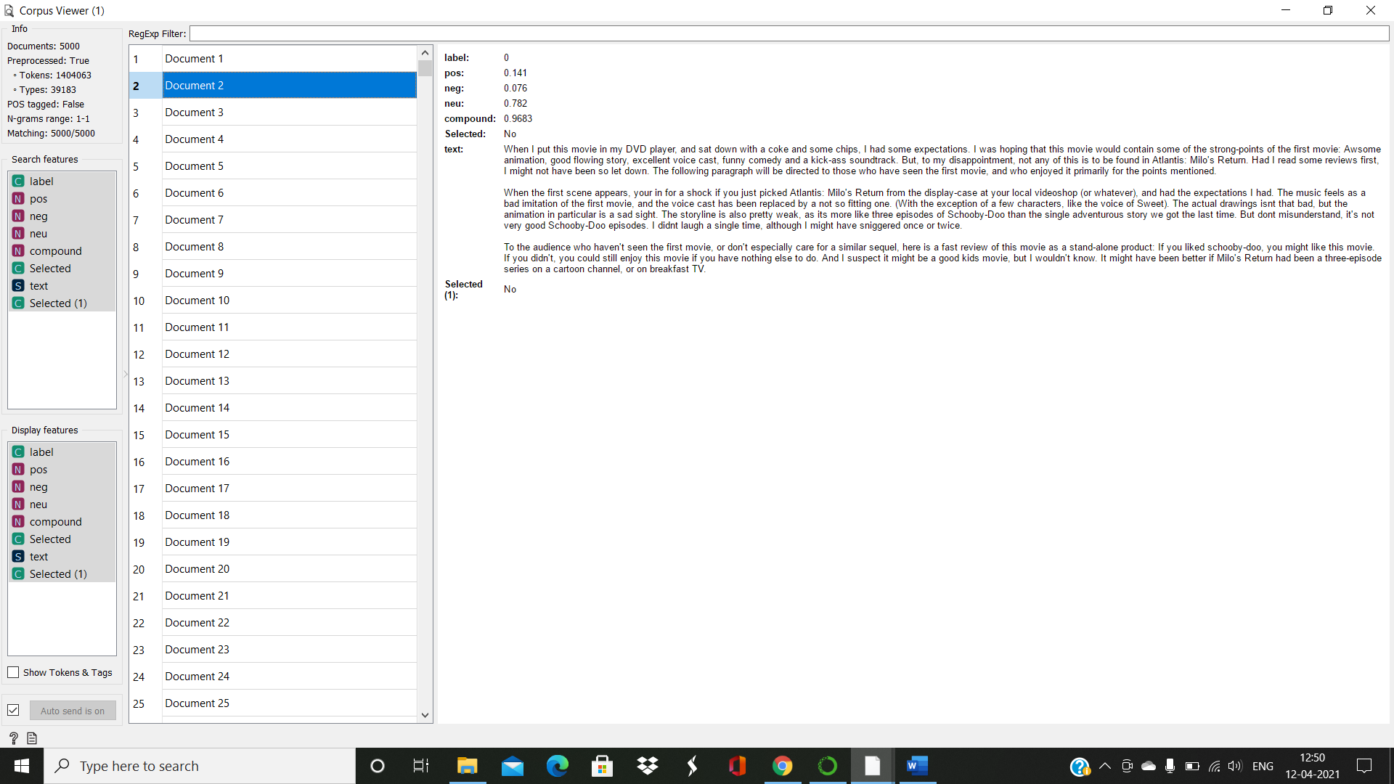

**The compound score is the sum of positive, negative & neutral scores which is then normalized between -1(most extreme negative) and +1 (most extreme positive). The more Compound score closer to +1, the higher the positivity of the text.**

Step 07 – Correlation Matrix

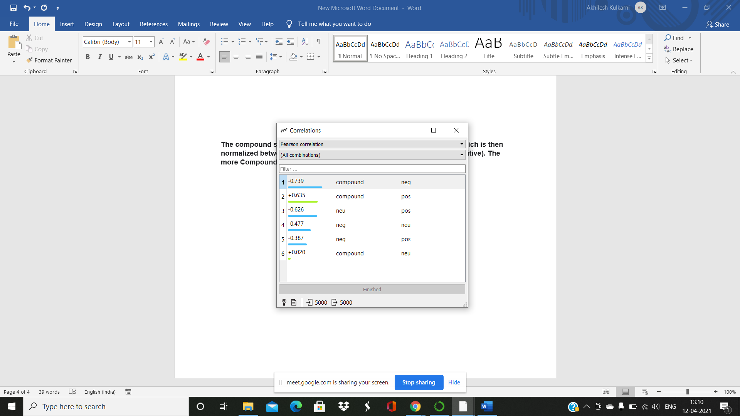

Step 08 – Data table to get quantitative information of each review

